Slide_1/

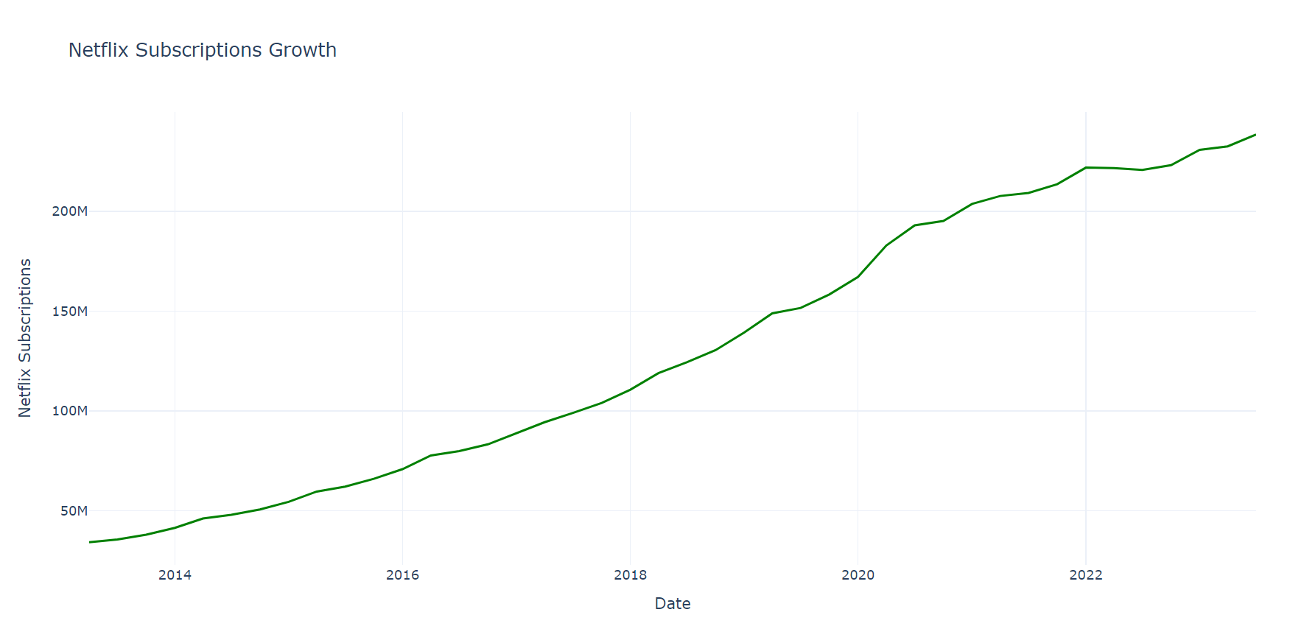

What to talk

Netflix experienced very fast growth from 2016 to 2020, likely due to entering new markets, releasing popular shows and movies, and effective marketing.

the company doubled its subscriber base in just three years, From 2014 to 2017.

1. The graph depicts a considerable rising trend in Netflix's total subscribers over time, demonstrating consistent subscriber growth.

2. You can detect periods of extremely strong growth, such as 2016 to 2020. This could be due to Netflix's expansion into new markets, exclusive content releases, or savvy marketing activities.

3.They crossed 100M in Oct 2017 and it took 3 years to reach that from when there are from 50M.

4.In Jan 2021 they crossed 200M.it took another 3yrs 3months to cross 200M

5. so it shows steady growth for the Netflix in terms of subscriptions.

Sldie2/: Netflix Quarterly Subscription Growth Rate.

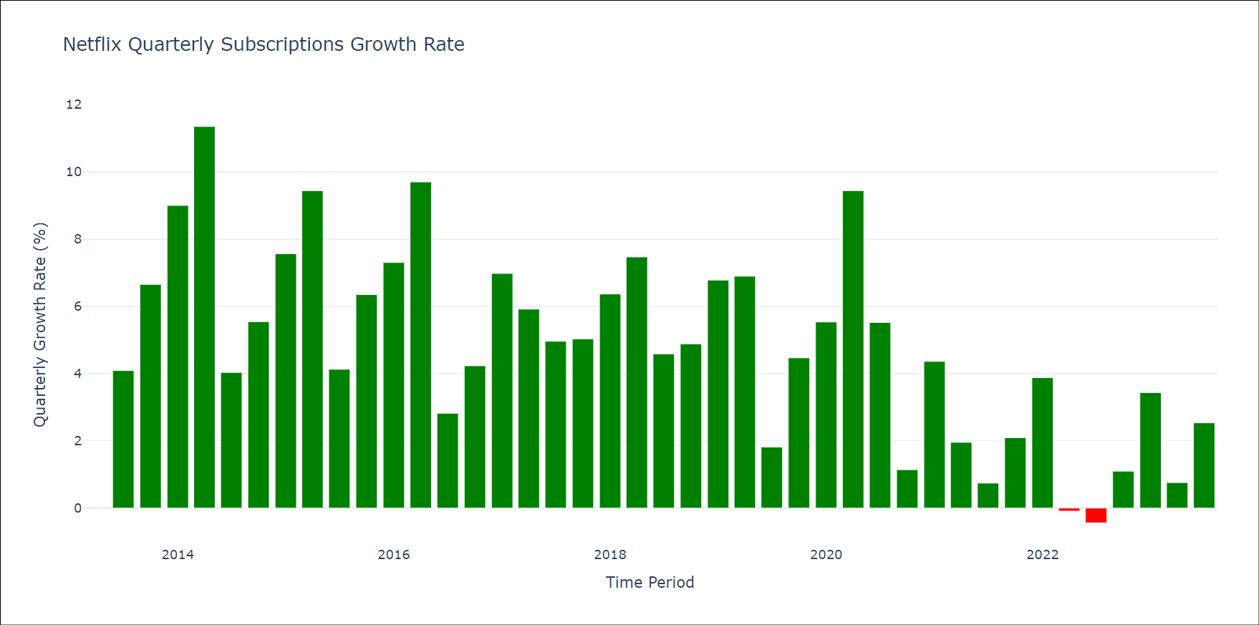

What to talk

The graph reveals a consistent upward trend in Netflix's user base, signaling a strong and steady growth pattern over the years.

Netflix experienced a decline in subscribers in the summer of 2022, likely due to the removal of popular shows and movies from the platform when licensing agreements ended. Additionally, increased competition and price hikes may have contributed to this drop in subscribers.

1. The graph illustrates a constant increasing trend in Netflix users, demonstrating a favorable growth trajectory over time.

2. The graph plainly shows that Netflix's subscription numbers increased dramatically between 2014 and 2020. In 2014 they had 12M subscribers and during 2020 it was 36.2M This tells that most of the users are subscribed to Netflix in this phase between 2014-2020. And the growth rate increased i

3.Netflix saw a Subscriber churn in the 2nd and 3rd Quarter of 2022 it could be because of Loss of popular content form the platform due to license expiration other reason include increased competition and increase in price.

4.

Slide3/: Netflix Subscription Growth Rate Forecasts

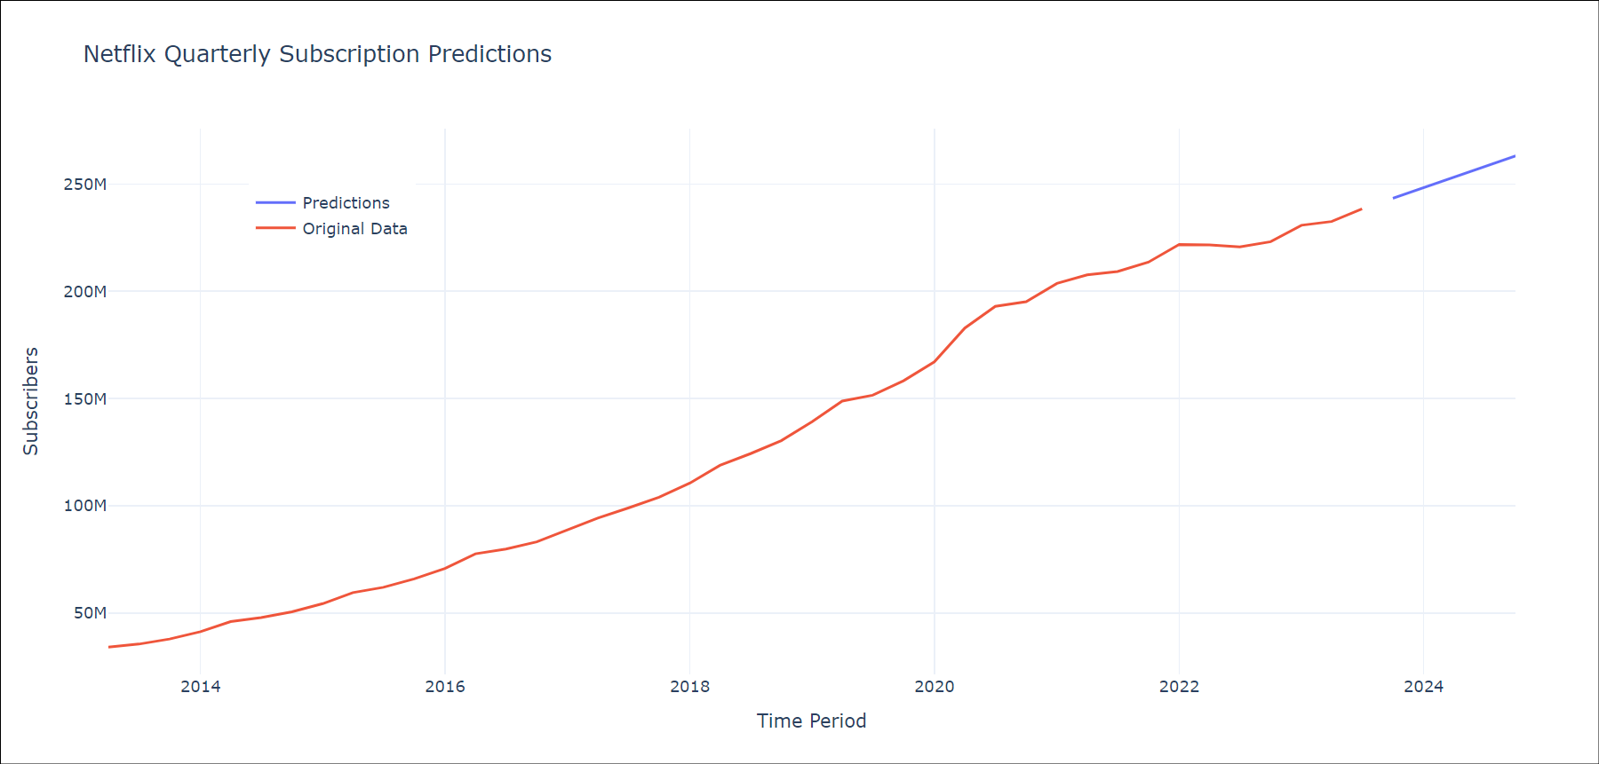

What you talk

a.used ARIMA modeling to predict subscription growth, helping them understand trends and seasonal patterns, and make informed decisions.

Netflix is tackling password sharing and expanding its offerings with tiered subscriptions, including an ad-supported option, to convert shared account users into paying customers and appeal to budget-friendly viewers, ultimately driving revenue and subscriber growth.

By the end of 2024, Netflix is projected to surpass 263 million subscribers, marking a significant milestone in its growth trajectory.

1. By the conclusion of the fourth quarter of 2024, the subscription growth is expected to be over 263 million.

2. Used the ARIMA (Autoregressive Integrated Moving Average) modeling technique to estimate Netflix subscription growth, exploiting its ability to capture both trend and seasonality in time-series data, thus offering significant insights for future planning and decision-making.

3. Netflix is implementing strategies such as cracking down on password sharing and introducing tiered subscriptions, including an ad-supported tier, to convert shared account users into paying subscribers while attracting budget-conscious viewers, potentially boosting revenue and subscriber growth.

Top of Form